Tunis International Environmental Technology Center (CITET)
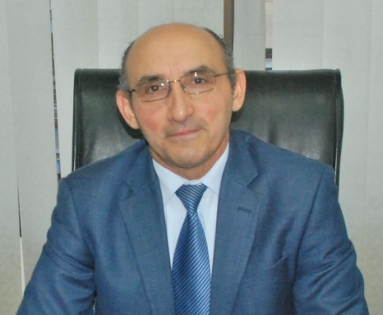

The Director General

Salah Hassini, PhD

"Our 2030 vision is to transform the Center into a modern regional platform for the assessment, transfer and adaptation of sustainable technologies", Inauguration address, February 15, 2018
On February 15, 2018, Dr Salah Hassini was appointed as Director General of Tunis International Environmental Technology Center (known as CITET).

Director General Hassini believes promoting sustainable technologies is among the most important priorities for Tunisia and the Mediterranean region. CITET should be a vital partner in such process.

As Director General, Dr. Hassini’s main goal is to turn the Center into a hub for innovative green technologies for the benefit of the economy and society as a whole.Priority will be given to climate change andsustainable wastewater and solid waste management systems.

Dr.Hassini, who holds a PhD degree in Engineering from the University of Michigan in Ann Arbor, believes that innovative technologies are essential for a sustainable future. North-south and south-south scientific and technological cooperation and technology transfer need to be encouraged and reinforced.

Prior to his latest nomination, Dr. Hassini served successively as Director General for Sustainable Development, Director General for Environment and Quality of Life both in the Ministry of Environment, andmost recently as Director General for the National Environmental Protection Agency (ANPE). He also was nominated for a relatively short period as interim General Manager for the National Office of Sanitation (ONAS).

During a long career devoted to environmental protection and sustainable development, Dr. Hassini made important contributions to the advancement of these strategic fields on local, national, regional and international levels. He helped addressing environmental challenges such as climate change, preservation of biodiversity and combating land degradation and pollution.

Dr. Hassini is a strong advocate of the rule of law and environmental and social justice which he thinks are important for sustainable development. He also believes that corruption has direct and/or indirect detrimental effects on environmental sustainability.

In addition, Dr. Hassini has a proven track record of working with others-especially private sector, governmental institutions, industry, educational system, civil society…- who want to contribute to environmental protection and sustainable management of natural resources. He strongly believes in partnership and cooperation between different social, economic and environmental stakeholders in order to overcome the challenges of sustainable development.

As Director of Industrial Environment, Director General of Environment and Quality of Life and member of the Board of Management of Compagnie des Phosphates de Gafsa (CPG) and Groupe Chimique Tunisien (GCT) for almost a decade, Dr. Hassini greatly contributed to solving environmental problems related to Tunisian phosphate sector thus making it more sustainable.

He also was the main force behind developing comprehensive air quality regulation and new version of industrial and domestic wastewater standards.

Dr. Hassini is married and has three children.

